Day | 6.30-7.30 am | 7.30-8.30  am | 8.30-9.30  am | 9.30-10.30  am | 10.30-11.30  am | 11.30-12.30  pm | 12.30- 1.30  pm | 1.30-2.30  pm | 2.30-3.30  pm | 3.30-4.30  pm | 4.30-5.30 pm | 5.30-6.30  pm | 6.30-7.30  pm | 7.30-8.30 pm | 8.30-9.30 pm | 9.30-10.30 pm | 10.30-11.30  pm
Mon
Tues
Wed |  |  |  |  |  |  |  |  |  |  | School Day
Thurs
Fri
Sat
Sun
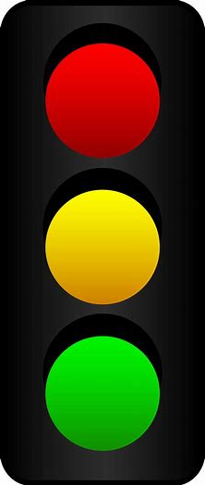
Name:

