From the Head Teacher |  |  |  |  | Coming Up  This week: LGBTQ+ History, PD Day 3, Y9 Battlefields trip.  Next week: Children’s Mental Health Week, Y7 Zoolab, Y10 Birmingham Field Trip, Y8 Options Evening
Our focus over the half term has been on Moorside Manners, and we continue to work with students on establishing these routines in line with our value of Community. It has been great to see the impact of this across the school with students working together to be kind and sensible around the site as we work through the colder weather when the corridors and canteen become naturally busier.
A personal thank you from myself to all students for engaging so well and for making this such a great school to work and learn in.
Have a good and restful weekend

Special Mentions

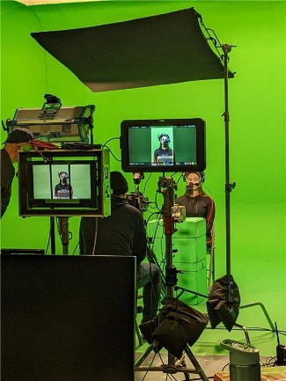
Behind the Scenes
Keep an eye out for our Year 11 student Georgie E, who has been filming for Nike. Here you can see a sneak-peek behind the scenes!
We are immensely proud of her success, which is well earned through hard work, enthusiasm, and commitment.

School News
Mental Health Tip:
Some people find it calming to pay attention to where they are physically. You can try to notice what you can see, hear, touch, and smell around you, going through each sense in turn.

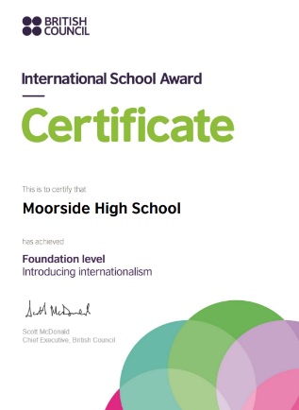
British Council International Award
Exciting news from MFL. We have been successful in our efforts to earn the British Council International School Award. We have the foundation certificate for "introducing internationalism" and are looking forward to developing our status in the future. Thank you to all pupils for their hard work and contributions, and to staff for their support for school wide initiatives.
Parent Forum  Our most recent Parent forum focussed on parent feedback around recent changes to Arbor communication, the Christmas concert and future planner designs. Our parent forum meets once per half term on a Tuesday evening (5-6pm). This is an opportunity for parents to raise issues, give their views and be a part of the school consultation on policies. All parents and carers are invited to come along. Our next meeting will be held on Tuesday 5th March where we will be completing out parent SWOT analysis which feeds into our annual School Development Plan. It would be fantastic to have as many parents attend as possible from a range of year groups. If you would be interested in joining our Parent Forum, please email Mrs Alcock. |  |  | Engineering Open Day  KMF Engineering are having an 'open day' on Saturday 10th February as part of National Apprenticeships Week. An ideal chance to look around their factory and find out about their apprenticeships. Booking is required (and is free). To reserve a place, go to the event page.

Engage

Y8 GCSE Pathways
On Monday the 29th of January we will begin our process of preparing Year 8 students to select their GCSE options. They will take part in a carefully planned Personal Development Day designed to support them in the decision-making process. We have staff from Higher Horizons coming in to support our careers team in the delivery of sessions on options available at MHS, post-16 options, going to university and local labour market information. We will then welcome parents and students to our Year 8 Parents' & Pathways evening on Thursday 8th February (4.30- 6.30pm) to discuss with teaching staff the best pathways for each student. We recommend every family attend this valuable opportunity to speak to staff and find out about GCSE options to ensure that every student can make a fully informed decision about their choices.

Book Reviews
We have 2 book reviews from 7KH this week. The first is from Aaliyah, who has written this review of ‘Harry Potter and the Philosopher’s Stone’:
“For many years Harry lived with his aunt and uncle, who had no interest in Harry. One day he was informed that he was a wizard. Harry went to wizard school and noticed strange goings on with some of his teachers, which leads to him making a shocking discovery. The reason I enjoyed this book because it is fantasy (my favourite genre), and it is about witches and wizards.”
The second is from Mr Hammonds himself, who has reviewed ‘The Song of Achilles’:
“I have recently finished reading ‘The Song of Achilles,’ a New York Times Bestseller, by Madeline Miller. This novel is an emotional re-telling of Homer’s Iliad, told from the perspective of Patroclus. An awkward young prince, exiled by his father and sent to a neighbouring kingdom, Patroclus is swept under the wing of Achilles, who is everything Patroclus is not; strong, handsome and a skilled warrior. As the two grow together and their friendship blossoms into something more, war erupts as word reaches the neighbouring kingdoms that Helen of Sparta is kidnapped. Patroclus follows Achilles into a sacking of Troy, that tests not just the mettle of the boys but their love for each other and everything they hold dear; casting the destinies of both, to the hands of Fate. This book has proven to be something quite different to my typical read, teaching me of several perspectives and attitudes, such as the fact that in modern depictions of Ancient Greece, LGBTQ history and community has been written out and forgotten. ‘The Song of Achilles’ has proven to revive this lost part of history while gripping and captivating me from start to finish.

Achieve
Sparx |  |  |  | Rank House House Points  1st Churchill 88747  2nd Moorcroft 82034  3rd Bridgewater 76790  4th Doulton 76687  5th Wedgwood 64127  House  Over the upcoming six months, we have an extensive line up of events as the House System calendar has been confirmed. Students will have the opportunity to engage in a diverse array of activities that cover our entire curriculum. Whether it is table tennis competitions, orienteering, or participation in events like the Great Moorside Bake or Moorside's Got Talent, there is something for everyone. We eagerly anticipate seeing our students actively participating in the upcoming events and competitions.
Swimming  Well done to the Year 7 and 8 girls swimming team who competed in the district gala last week. They finished in a brilliant 2nd place after some fantastic performances in the individual races and team relays! Well done to Ellie, Sophia, Alice, Ruby, Skye, and Emilia. |  |  |  | Football  Well done to the Year 8/9 girls 6-a-side team who played in the district tournament on Tuesday. They played 4 games, winning 6-0, 6-1, 9-1 and 12-0! A fantastic performance all round! Well done to Lily, Sydney, Immy, Ellie, Ava, Annaleigh, and Amelia. Also, a big thanks to Leah in Year 10, who stayed to referee the matches and was an immense help!

